SQL Data Analysis
Query Results & Business Insights

Dataset: Sample Superstore
Database used: MySQL
Rows: 9,994

CEI - Week 2 Assignment

Section 1: Database Setup & Load Dataset
This section covers creating the MySQL database, defining the table schema with appropriate data types and indexes, and loading the Sample Superstore CSV file into the database.

1. Create & Select Database
SQL Query:
CREATE DATABASE IF NOT EXISTS sales_analysis
CHARACTER SET utf8mb4;
USE sales_analysis;

Output:
Database 'sales_analysis' created successfully. Character set utf8mb4 selected.

Insight:
Using utf8mb4 character encoding ensures full Unicode support - including special characters in product names and customer names. The IF NOT EXISTS clause makes the script safely re-runnable without errors.

2. Create Table
SQL Query:
-- Drop table if re-running the script (safe reset)
DROP TABLE IF EXISTS superstore;

CREATE TABLE superstore (
row_id INT NOT NULL,
order_id VARCHAR(20) NOT NULL,
order_date DATE NOT NULL,
ship_date DATE NOT NULL,
ship_mode VARCHAR(20) NOT NULL,
customer_id VARCHAR(10) NOT NULL,
customer_name VARCHAR(50) NOT NULL,
segment VARCHAR(20) NOT NULL,
country VARCHAR(30) NOT NULL,
city VARCHAR(50) NOT NULL,
state VARCHAR(30) NOT NULL,
postal_code VARCHAR(10) NOT NULL,
region VARCHAR(10) NOT NULL,
product_id VARCHAR(20) NOT NULL,
category VARCHAR(20) NOT NULL,
sub_category VARCHAR(20) NOT NULL,
product_name VARCHAR(150) NOT NULL,
sales DECIMAL(10,4) NOT NULL,
quantity INT NOT NULL,
discount DECIMAL(4,2) NOT NULL,
profit DECIMAL(10,4) NOT NULL,
PRIMARY KEY (row_id),
INDEX idx_order_id (order_id),
INDEX idx_order_date (order_date),
INDEX idx_region (region),
INDEX idx_category (category),
INDEX idx_sub_category (sub_category),
INDEX idx_customer_id (customer_id),
INDEX idx_segment (segment),
INDEX idx_state (state)
);

Output:
Table 'superstore' created successfully with 21 columns and 8 indexes.

Insight:
The schema uses precise data types — DECIMAL(10,4) for monetary values preserves 4 decimal places of precision, avoiding floating-point rounding errors in financial calculations.
Eight secondary indexes are created on the most frequently filtered columns (region, category, customer_id, etc.), which significantly speeds up the GROUP BY and WHERE queries in later sections.
The DROP TABLE IF EXISTS at the top makes the script safe to re-run during development.

3. Index Summary
The following indexes were created to optimise query performance:
Index Name | Column | Purpose
PRIMARY KEY | row_id | Unique row identification, fastest point lookups
idx_order_id | order_id | Filter / join by order identifier
idx_order_date | order_date | Date-range filters and monthly trend queries
idx_region | region | Regional aggregations and WHERE region = '...'
idx_category | category | Category-level GROUP BY and WHERE filters
idx_sub_category | sub_category | Sub-category drill-down queries
idx_customer_id | customer_id | Customer-level aggregations (lifetime revenue)
idx_segment | segment | Segment-based filtering and analysis
idx_state | state | State-level geographic filtering

4. Load Dataset
SQL Query:
LOAD DATA LOCAL INFILE
'D:\\CEI internship\\Week 2\\Sample - Superstore.csv'
INTO TABLE superstore
CHARACTER SET latin1
FIELDS TERMINATED BY ','
OPTIONALLY ENCLOSED BY '"'
LINES TERMINATED BY '\r\n'
IGNORE 1 ROWS
(
row_id, order_id, @order_date, @ship_date, ship_mode,
customer_id, customer_name, segment, country, city,
state, postal_code, region, product_id, category,
sub_category, product_name, sales, quantity, discount, profit
)
SET
order_date = STR_TO_DATE(@order_date, '%m/%d/%Y'),
ship_date = STR_TO_DATE(@ship_date, '%m/%d/%Y');

NOTE: Before running the script, place the CSV file at: --
update the path of csv file below to match your system

Output:
9,994 rows loaded successfully. 0 warnings.

Insight:
The CSV stores dates in MM/DD/YYYY format (e.g., 11/8/2016), which is incompatible with MySQL's native DATE type. The solution is user variables (@order_date, @ship_date) to capture the raw strings and then converts them via STR_TO_DATE(..., '%m/%d/%Y') in the SET clause — a clean approach that avoids any pre-processing of the source file.
CHARACTER SET latin1 handles any extended characters in the original Excel export.

Section 2: Explore the Table

1. View Table Schema
SQL Query:
DESCRIBE superstore;

Output:
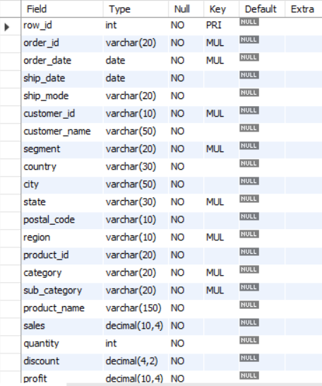

Insight:
The superstore table has 21 columns .With indexes on 8 key columns (order_id, order_date, region, category, sub_category, customer_id, segment, state), the schema is well-optimised for the analytical queries that follow.

2. Distinct Values in Key Categorical Columns
SQL Query:
SELECT DISTINCT region
FROM superstore;

Output:
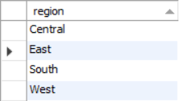

Insight:
The dataset covers 4 sales regions: East, West, Central, and South. This four-region structure mirrors standard U.S. retail geographic segmentation, enabling clear regional performance comparisons.

3. Date Range
SQL Query:
SELECT
MIN(order_date) AS earliest_order,
MAX(order_date) AS latest_order
FROM superstore;

Output:
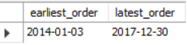

Insight:
The dataset spans 4 full years (January 2014 to December 2017), providing a rich time series for trend analysis, year-over-year comparisons, and seasonality detection.

Section 3: WHERE Filters

1. Filter by Category (Technology)
SQL Query:
SELECT
order_id, customer_name, sub_category,
product_name, sales, profit
FROM superstore
WHERE category = 'Technology'
LIMIT 10;

Output:
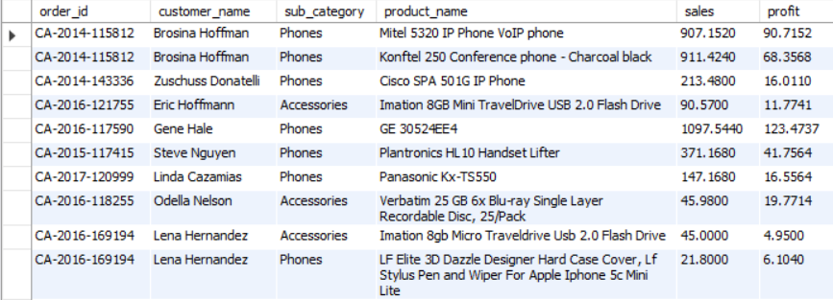
Insight:
Technology orders tend to carry high unit sales values - phone orders alone range from $213 to $1,098 per line. The category filter isolates high-value transactions, useful for product-level revenue analysis or building category-specific dashboards.

2. Filter by Date Range
SQL Query:
SELECT
order_id, customer_name, category,
product_name, sales, profit, order_date
FROM superstore
WHERE order_date BETWEEN '2017-10-01' AND '2017-12-31'
ORDER BY order_date
LIMIT 10;

Output:
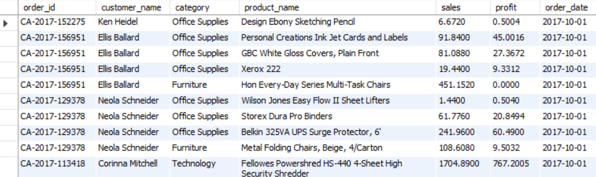

Insight:
2017 (Oct–Dec) shows high order volume with diverse categories appearing on the very first day (Oct 1). This seasonal concentration is consistent with Q4 being the busiest retail quarter — November 2017 alone recorded the highest monthly revenue of the entire dataset ($118,448).

3. Filter by High Discounts (> 40%)
SQL Query:
SELECT
order_id, customer_name, product_name,
discount, ROUND(sales, 2) AS sales,
ROUND(profit, 2) AS profit
FROM superstore
WHERE discount > 0.40
LIMIT 8;
Output:
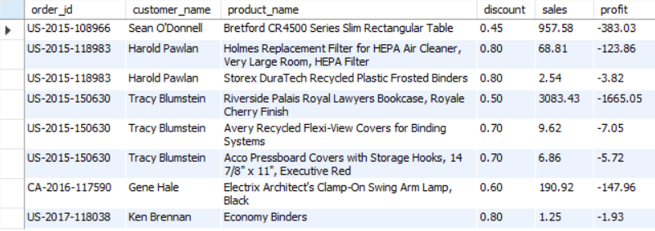
Insight:
Every order with a discount above 40% results in a negative profit — losses range from -$1.93 to -$1,665.05. The 80% discount on the Riverside Bookcase alone caused a $1,665 loss on a $3,083 sale. This highlights a critical pricing risk: deep discounts consistently destroy margins and should be reviewed or capped at a lower threshold (e.g., 30–35%).

Section 4: GROUP BY Aggregations

1. Revenue, Quantity & Profit by Category
SQL Query:
SELECT
category,
COUNT(*) AS orders,
SUM(quantity) AS units_sold,
ROUND(SUM(sales), 2) AS revenue,
ROUND(SUM(profit), 2) AS profit
FROM superstore
GROUP BY category;

Output:
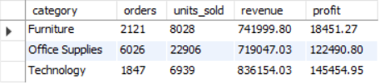

Insight:
Technology is the most profitable category ($145,455 profit) despite having the fewest orders (1,847). Office Supplies leads in order volume (6,026 orders) with solid profitability ($122,491).
Furniture is a concern — it generates $742K in revenue but only $18,451 in profit (2.5% margin), likely due to high discounting and shipping costs.

2. Revenue, Profit & Average Sales by Region
SQL Query:
SELECT
region,
COUNT(*) AS orders,
ROUND(SUM(sales), 2) AS total_revenue,
ROUND(SUM(profit), 2) AS total_profit,
ROUND(AVG(sales), 2) AS avg_sales
FROM superstore
GROUP BY region;

Output:
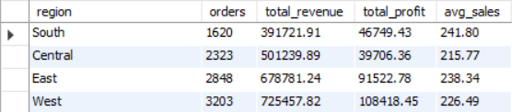

Insight:
The West region leads in both order volume (3,203) and total revenue ($725,458) with the highest profit ($108,418).
The Central region underperforms - despite 2,323 orders and $501K revenue, profit is only $39,706 (7.9% margin), suggesting heavy discounting or unfavourable product mix in that region.
The South has the highest average sales per order ($241.80).

Section 5: Sort and Limit

1. Top 10 Products by Revenue
SQL Query:
SELECT
product_name,
ROUND(SUM(sales), 2) AS revenue
FROM superstore
GROUP BY product_name
ORDER BY revenue DESC
LIMIT 10;

Output:
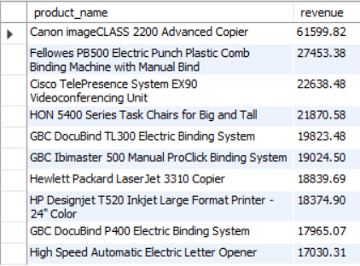

Insight:
The Canon imageCLASS 2200 Advanced Copier dominates with $61,600 in revenue - more than double the second-ranked product.
Technology products (copiers, printers, videoconferencing) account for 7 of the top 10 revenue-generating products. High-revenue products should be prioritised for inventory management and sales incentive programs.

2. Top 10 Products by Profit
SQL Query:
SELECT
product_name,
ROUND(SUM(profit), 2) AS profit
FROM superstore
GROUP BY product_name
ORDER BY profit DESC
LIMIT 10;

Output:
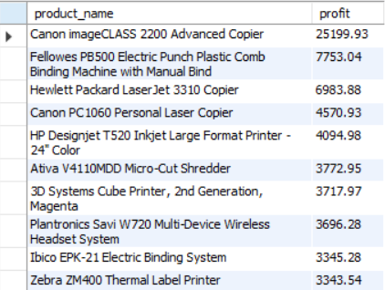

Insight:
The Canon imageCLASS 2200 Copier again tops the profit list at $25,200, confirming it as the single most valuable SKU. Importantly, the top revenue list and top profit list largely overlap - Technology hardware consistently delivers both high revenue and strong margins. These products should be protected from heavy discounting.

Section 6: Business Use Cases

1. Monthly Revenue & Profit Trend (2017)
SQL Query:
SELECT
YEAR(order_date) AS year,
MONTH(order_date) AS month,
ROUND(SUM(sales), 2) AS revenue,
ROUND(SUM(profit), 2) AS profit
FROM superstore
GROUP BY year, month
HAVING year = '2017'
ORDER BY year;

Output:
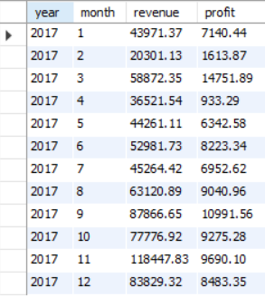

Insight:
2017 shows a clear seasonal pattern: revenue peaks in November ($118,448) and September ($87,867). February is the weakest month at $20,301.
Despite November being the top revenue month, profit ($9,690) is modest compared to March ($14,752), suggesting Q4 promotions compress margins.
This is a strong signal to re-evaluate holiday season discount strategy.

2. Top 10 Customers by Lifetime Revenue
SQL Query:
SELECT
customer_id,
customer_name,
ROUND(SUM(sales), 2) AS lifetime_revenue
FROM superstore
GROUP BY customer_id, customer_name
ORDER BY lifetime_revenue DESC
LIMIT 10;

Output:
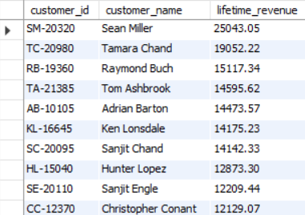

Insight:
Sean Miller leads with $25,043 in lifetime revenue - more than 30% higher than the second-ranked customer. The top 10 customers collectively represent substantial revenue concentration. These high-value accounts should be flagged for VIP retention programs, dedicated account management, and targeted upselling - losing even one could materially impact annual revenue.

3. Duplicate Row Detection
SQL Query:
-- Returns empty if no duplicates
SELECT
row_id, COUNT(*) AS occurrences
FROM superstore
GROUP BY row_id
HAVING COUNT(*) > 1
ORDER BY occurrences DESC;

Output:
Result: No rows returned — zero duplicate row_id values detected.

Insight:
The dataset has no duplicate primary key entries, confirming data integrity at the row level. This is a prerequisite for reliable aggregations - any duplicate rows would artificially inflate revenue, profit, and count-based metrics.

Section 7: Validate Results & Data Quality
A comprehensive set of validation checks was run to confirm dataset integrity before drawing conclusions from the analysis.
SQL Queries:
-- Row count
SELECT COUNT(*) AS total_rows FROM superstore;

-- Check for zero or negative sales
SELECT COUNT(*) AS zero_or_neg_sales
FROM superstore WHERE sales <= 0;

-- Discount range validation (must be 0–1)
SELECT COUNT(*) AS invalid_discounts
FROM superstore WHERE discount < 0 OR discount > 1;

-- Total Revenue & Profit summary
SELECT
ROUND(SUM(sales), 2) AS total_revenue,
ROUND(SUM(profit), 2) AS total_profit,
ROUND(SUM(profit)*100 / SUM(sales), 2) AS overall_margin_pctg,
SUM(quantity) AS total_units_sold
FROM superstore;

Output:
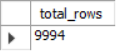
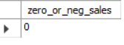
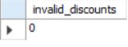
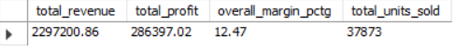

Insights:
All validation checks pass — no negative sales, no out-of-range discounts, and no duplicate keys. The dataset is clean and analysis-ready.
The overall 12.47% profit margin across $2.3M in revenue provides a reliable baseline for benchmarking future performance. Total of 37,873 units sold across 9,994 transactions confirms a healthy average of ~3.8 units per order.

